**EXERCISES**

1. To display the employee name, department name, and location of all employees who earn a commission.

1. **SELECT ENAME, DNAME, LOC, COMM FROM EMP INNER JOIN DEPT ON EMP.DEPTNO=DEPT.DEPTNO WHERE COMM >0;**
2. **SELECT ENAME, DNAME, LOC, COMM FROM EMP NATURAL JOIN DEPT WHERE COMM>0;**
3. **SELECT E. ENAME, D. DNAME, D.LOC, E. COMM FROM EMP E, DEPT D WHERE E. DEPTNO=D.DEPTNO AND COMM > 0;**

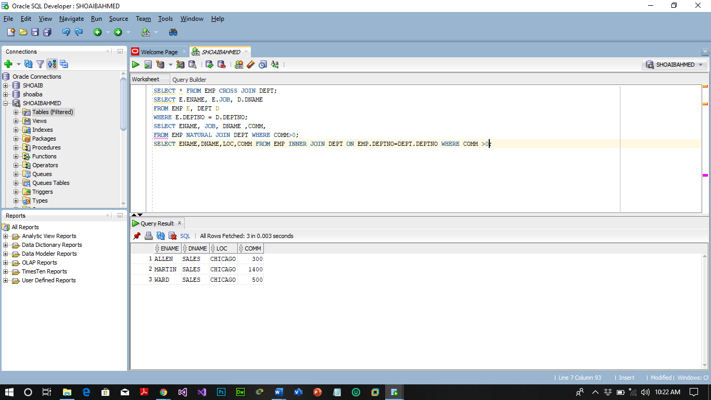

1. To display all the employee’s name (including KING who has no manager) and their manager name.

**SELECT W. ENAME EMPLOYEE, M. ENAME MANAGER FROM EMP W LEFT OUTER JOIN EMP M ON W.MGR =M. EMPNO;**

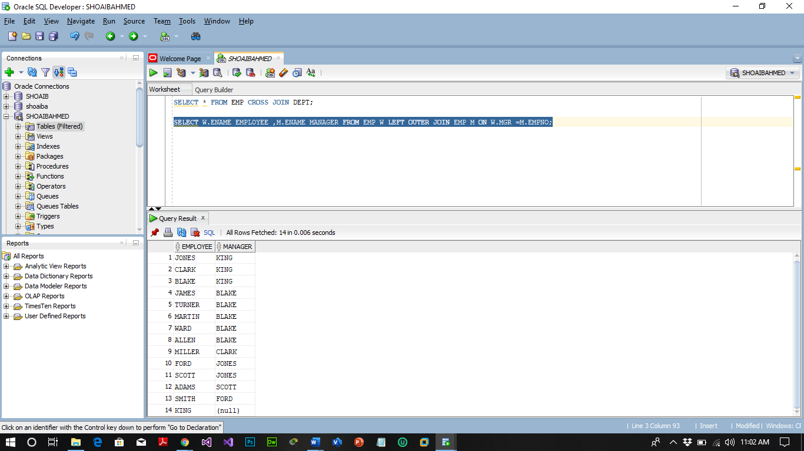

1. To display the name of all employees whose manager is ***KING***.

**SELECT W. ENAME EMPLOYEE, M. ENAME MANAGER FROM EMP W LEFT OUTER JOIN EMP M ON W.MGR =M. EMPNO WHERE M. ENAME ='KING';**

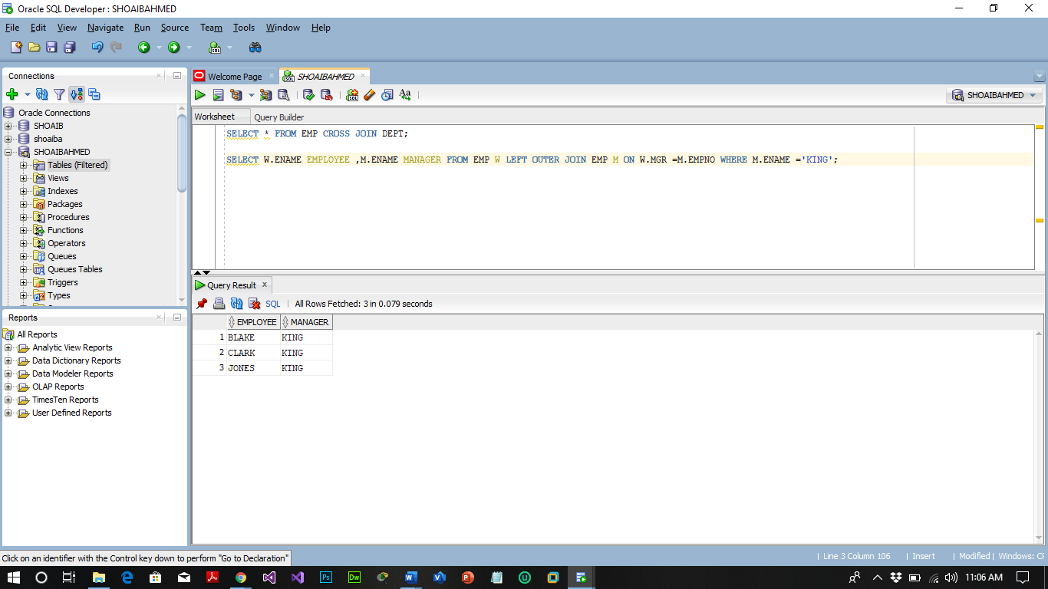

1. Write a query to display the name, job, department number and department name for all employees who work in DALLAS.

**SELECT E. ENAME, E.JOB, D. DEPTNO, D. DNAME FROM EMP E, DEPT D WHERE E. DEPTNO=D.DEPTNO AND LOC ='DALLAS';**

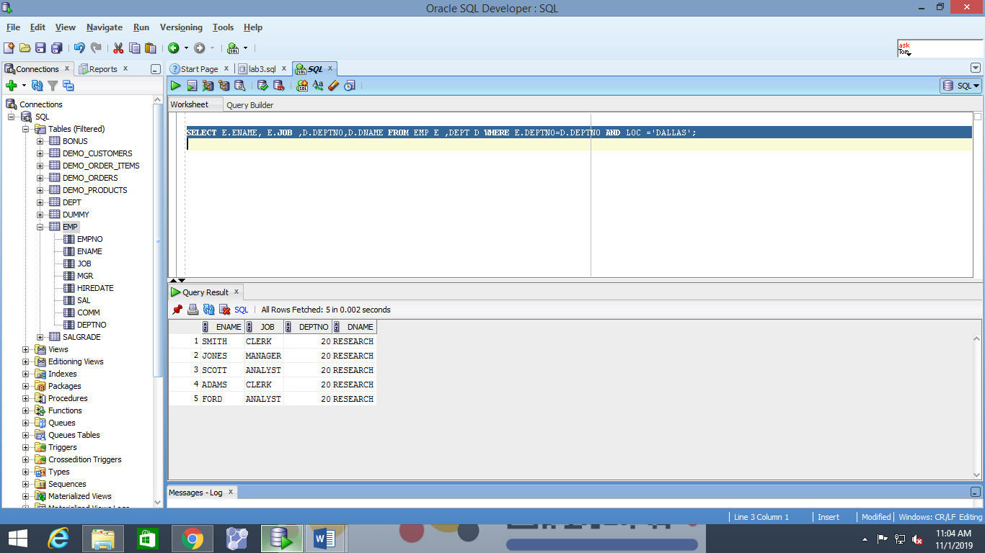

1. Display the employee name and employee number along with their manager’s name Manager Number. Label the columns Employee, Emp#, Manager, and Manager#, respectively.

**SELECT W. ENAME "Employee", W. EMPNO "EMP#”, M. ENAME "Manager", M. EMPNO "Mgr#" FROM EMP W LEFT OUTER JOIN EMP M ON W.MGR = M. EMPNO;**

